Kiran Girish

Period 4

4/28/16

Distance: 210469.4253289617

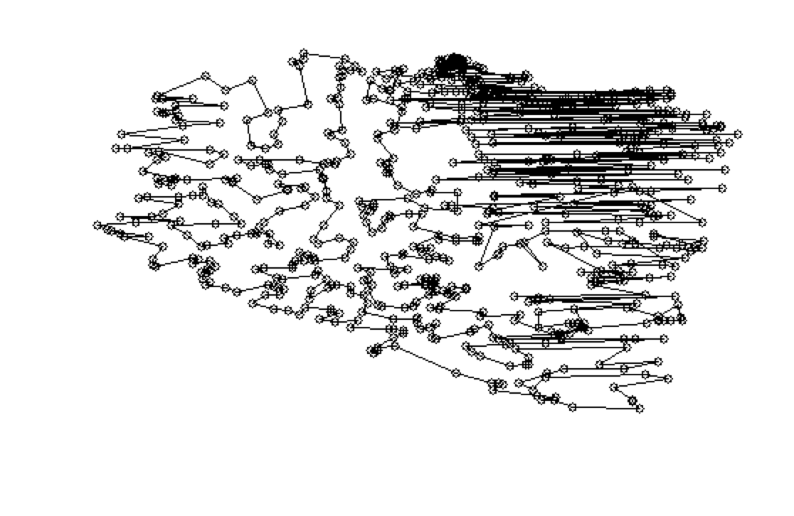

Path

[1, 3, 6, 11, 16, 18, 17, 19, 10, 15, 21, 22, 27, 25, 36, 34, 28, 26, 24, 23, 29, 31, 38, 39, 40, 41, 47, 46, 45, 44, 43, 50, 83, 95, 92, 98, 104, 108, 113, 125, 147, 143, 151, 140, 132, 134, 131, 142, 157, 156, 176, 178, 179, 167, 168, 150, 159, 160, 161, 163, 137, 119, 112, 107, 111, 114, 139, 155, 166, 175, 189, 203, 199, 186, 200, 207, 230, 235, 233, 224, 220, 227, 231, 239, 244, 243, 251, 284, 274, 267, 268, 272, 280, 277, 300, 328, 329, 324, 321, 316, 298, 291, 310, 323, 334, 342, 351, 341, 355, 360, 339, 335, 371, 370, 378, 369, 386, 414, 413, 423, 432, 434, 450, 484, 491, 506, 550, 561, 597, 582, 653, 639, 635, 636, 689, 680, 684, 676, 656, 670, 662, 657, 660, 666, 658, 659, 665, 664, 663, 711, 710, 709, 708, 707, 706, 705, 704, 703, 702, 701, 700, 699, 698, 697, 696, 695, 722, 715, 714, 713, 726, 727, 728, 729, 730, 731, 733, 732, 725, 721, 720, 719, 718, 717, 716, 678, 686, 685, 687, 688, 691, 690, 682, 654, 655, 681, 677, 674, 672, 671, 669, 673, 638, 637, 640, 651, 650, 645, 646, 642, 643, 644, 647, 649, 648, 626, 620, 625, 627, 628, 629, 609, 615, 619, 616, 610, 611, 612, 613, 614, 618, 617, 621, 622, 623, 624, 633, 632, 630, 631, 605, 606, 604, 607, 598, 599, 600, 601, 602, 583, 587, 574, 570, 573, 571, 572, 575, 576, 577, 578, 579, 580, 581, 591, 585, 590, 589, 584, 586, 588, 592, 567, 563, 555, 556, 557, 558, 559, 560, 562, 564, 552, 551, 548, 541, 542, 543, 544, 533, 534, 535, 536, 537, 539, 538, 529, 530, 510, 521, 525, 526, 527, 523, 517, 518, 519, 520, 522, 507, 511, 514, 508, 512, 509, 513, 515, 503, 504, 497, 498, 499, 500, 501, 488, 489, 492, 493, 490, 494, 486, 485, 483, 478, 479, 480, 481, 475, 476, 472, 473, 470, 465, 462, 463, 458, 459, 460, 453, 454, 455, 451, 448, 446, 447, 449, 435, 442, 443, 436, 438, 439, 426, 422, 424, 421, 418, 416, 419, 410, 411, 412, 408, 400, 401, 402, 395, 392, 390, 387, 381, 379, 374, 375, 368, 372, 364, 365, 336, 340, 346, 345, 357, 352, 353, 348, 343, 337, 338, 330, 332, 331, 325, 326, 322, 317, 312, 313, 314, 384, 305, 306, 301, 205, 234, 236, 252, 261, 208, 265, 294, 295, 296, 209, 213, 212, 215, 229, 237, 292, 269, 270, 262, 263, 256, 257, 271, 281, 289, 248, 242, 240, 247, 246, 253, 245, 266, 195, 196, 190, 191, 192, 187, 184, 180, 181, 182, 165, 169, 170, 171, 162, 133, 126, 124, 123, 127, 120, 121, 118, 100, 66, 72, 73, 74, 75, 67, 68, 76, 105, 110, 109, 93, 84, 85, 79, 80, 81, 86, 91, 115, 77, 63, 58, 56, 53, 54, 51, 69, 60, 55, 42, 49, 71, 65, 62, 70, 90, 89, 88, 97, 117, 130, 135, 149, 154, 153, 146, 122, 138, 174, 194, 183, 173, 177, 198, 201, 202, 211, 217, 218, 238, 232, 225, 223, 219, 226, 241, 264, 276, 260, 273, 304, 344, 359, 373, 406, 405, 417, 409, 420, 429, 428, 425, 444, 445, 441, 430, 433, 431, 437, 457, 477, 487, 502, 505, 569, 596, 603, 641, 661, 668, 679, 693, 683, 675, 694, 724, 734, 723, 712, 692, 568, 554, 528, 496, 474, 469, 471, 532, 547, 652, 634, 667, 608, 595, 594, 593, 566, 565, 553, 549, 546, 545, 540, 531, 524, 516, 495, 482, 468, 467, 466, 456, 427, 464, 461, 452, 440, 415, 407, 393, 403, 388, 385, 396, 397, 398, 404, 399, 394, 391, 356, 377, 376, 389, 383, 380, 363, 347, 333, 311, 299, 255, 259, 288, 290, 287, 286, 283, 275, 258, 254, 250, 282, 303, 307, 308, 320, 350, 354, 382, 367, 366, 362, 361, 358, 349, 327, 319, 318, 315, 309, 302, 297, 285, 293, 279, 278, 249, 221, 210, 204, 228, 222, 214, 216, 206, 197, 193, 188, 185, 172, 164, 158, 144, 136, 152, 148, 145, 141, 129, 128, 116, 102, 101, 94, 106, 103, 99, 96, 87, 78, 82, 64, 61, 59, 57, 52, 48, 32, 30, 33, 35, 37, 14, 13, 12, 9, 8, 7, 4, 5, 2, 20]